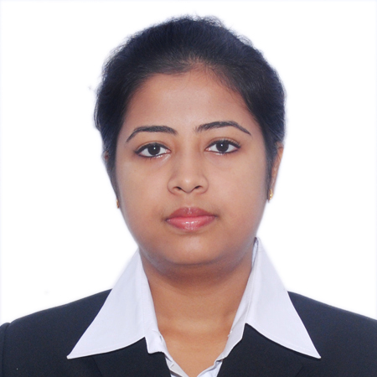

**SUSMITA BAIDYA**

**Age:** 27 **Gender:** Female

**E-mail:**susmitabaidya3110@gmail.com **Contact No.+**919883640318

**Address:** Udita complex, UD050701 survey park,Santoshpur.Kolkata. WB- 700075

**ACADEMICQUALIFICATION**

|  |  |  |  |  |  |  |
| --- | --- | --- | --- | --- | --- | --- |
| **sACADEMIC QUALIFICATION** | **Year** | **Examination** | **Institute** | **Board/University** | **Percentage** |  |
| 2014 | MBA | Bengal Institute of Business Studies | V.U | 61% |
| 2014 | PGPBM | Bengal Institute of Business Studies | Autonomous | 65% |
| 2011 | B.Com | Bongaigaon College | G.U | 48% |
| 2008 | HIGHER SECONDARY | Bongaigaon College | SEBA | 53% |
| 2006 | MADHYAMIK | S.K.B High School | SEBA | 63% |

**WORK EXPERIENCE**

**Star Union Dai-ichi Life**

**Designation:** Relationship Manager

**Duration:** 4th June’16 to till now

**Profile:**

Customize insurance programs to suit individual customers, often covering a variety of risks

Maintaining relationship with bankers and gather leads from bank’s data base

Ensure that policy requirements are fulfilled, including any necessary medical examinations and the completion of appropriate forms

Calculate premium and establish payment method

Seek out new clients and develop clientele by networking to find new customers and generate lists of prospective clients

Perform administrative tasks, such as maintaining records and handling policy renewals

Interview prospective clients to obtain data about their financial resources and needs, the physical condition of the person and to

discuss any existing coverage

**Dr. Paul’s multispecialty clinic**

**Designation:** Business Development Manager

**Duration:** 1st June’15 to 31st October’15

**Profile:**

Developing and maintaining new and existing accounts, ensuring meaningful engagement and maximizing revenue

Potential

Manage client relationships to ensure revenue growth and inquiry generation for advice service

Planning with the panel corporate for the branding & also for the business development

Understanding competitors and providing valid USP s in capturing sales

Identifies product improvements or new products by remaining current on industry trends, market activities, and

Competitors

Responsible for Ensuring smooth functioning, standardization of clinics

**India Ratings & Research (A Fitch Group)**

**Designation:** Business Development Officer

**Duration:** 1st August’14 to 31st May’15

**Profile:**

Responsible for generating revenue for organization by selling performance and credit rating scheme to various micro,

Small, medium and large enterprises which includes proprietorship/partnership/pvt ltd firms

Identified & developed new streams for revenue growth & maintained relationships with SME, large corporate and also

Managers/AGM’s/DGM’s of nationalized banks in order to achieve repeat business.

Conducted competitor analysis by keeping abreast of trends & competitor moves to achieve market share metrics

Prepared monthly sales report, weekly plan, target projection for month & MIS reports to keep management updated

**ONICRA credit rating agency of India Ltd.**

**Designation:** Business Development Executive

**Duration:** 28th September’13 to 31st July’14

**Profile:**

Assessment of SME firm for credit rating, presentations on Onicra credit rating and its benefits to corporate houses,

Making tie ups with nationalized banks

**KEY SKILLS**

Coordination with representatives from other departments to ensure the flawless execution of my work. Manage inter-department dependencies to make sure the smooth execution of cases. Provide daily progress updates on my cases and my team. Issues update in master issue register and continual follow-up for timely resolution and identify risks and issues associated with the projects. Escalate all day to day issues to the line manager for early resolution on any issues.

**ACHIEVEMENTS**

Exceeded targets on monthly basis

Received awards from superior, earned high incentives

Quickly promoted from Assistant relationship manager to Relationship manager due to organizational abilities and strong work ethic

**SUMMER INTERNSHIP**

**Reliance digital Duration: April’13 – June’13**

**Purpose**: Pitching for Reliance Stores in house brand “Reconnect” and developing a structured customer satisfaction level assessment process for increasing sales volume

**Method**:

* Conducted a survey through questionnaire
* Collected the database of all the customer on a weekly basis so as to gather their feedback over telephone

**Learning:**

* Derived an understanding about the customer feedback process and problem escalation so as to ensure their quick resolution
* Developed a better understanding about Retail Store operations and approached customers to buy products

**KEY PROJECTS**

* **Comparative Analysis :**Studied the competition faced by genuine branded products from fake products in the rural market
* **Dive in to Dhamaka :** Conducted an analysis of the impact of the end of season sale and its impact on marketing mix, conversation ratio, new customer addition in retail outlet like Jack & Jones
* **Cancer Awareness project :** Surveyed on the effect of tobacco on teenagers and causes of oral cancer and its prevention
* **City Scan :** Comparative study of price variations of panel in unorganized retail stores compared with the gray market at fancy bazaar in Kolkata

**OTHER INTERESTS**

* Fond of painting
* Passionate in interior decorating